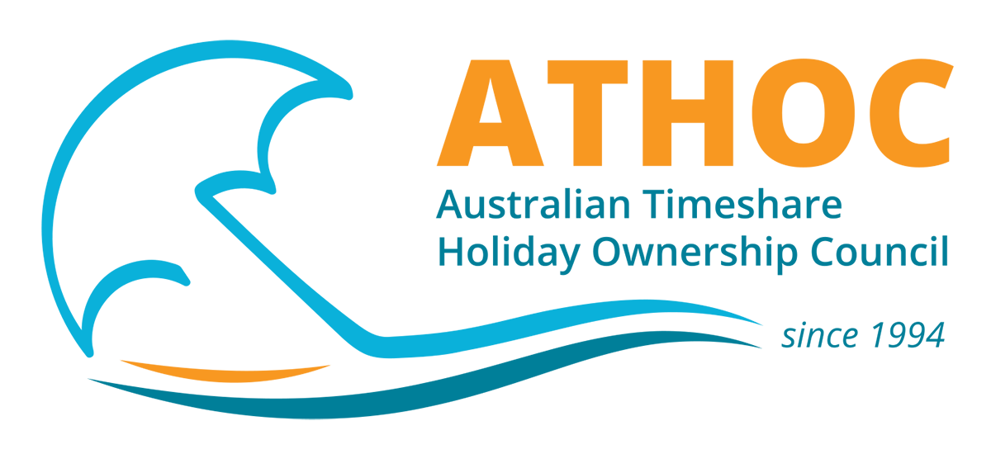 ATHOC 2021 Conference
Monday Night and Tuesday - 10th and 11th October

Conference Registration Form and Dinner
PERSONAL DETAILS

Name:

Company Name:

Contact Person:

Phone Number: Email:

Full Conference Delegate –
Includes Monday night welcome drinks, and attendance at all sessions Tuesday

Early Bird - Payment received before 3rd September 2021  x Early Bird Member per person - $190pp  x Early Bird Non-member - $295pp |  | Standard - Payment received after 3rd September 2021  x Standard Registration, Member - $225.00pp  x Standard Registration, Non-Member -$395.00pp
Name of Delegate/s:

Sub Total $

REGISTRATION OF ADDITIONAL GUESTS Drinks and Nibbles from 5.00 to 7.00
Monday 9th September - Extra Tickets

Early Bird Payment - received before 3rd September 2021

X Member Early Bird Guests Registration $60.00pp
x Non Member Early Bird Guests - $80.00pp

Standard Payment - received after 3rd October 2021
x Standard Registration - $65.00pp
x Non Member Standard Registration - $85.00pp

Total $

Please list additional guests

Name of Guest/s:

Tuesday 10th September: ATHOC Dinner
Please register all guests who you wish to attend this event

Name of Additional Guest/s:

Early Bird Payment - received before 3rd September 2021

x Early Bird Registration - $145

x Non Member Early Bird- $190
x Standard Registration - $165.00pp
x Non Member Standard Registration - $210.00pp

Total $

Payment Details
Payment method
Bank Transfer - Westpac Southport, QLD Australia
BSB: 034 215 Account: 318 222 Ref: (Please use your company name as the reference)

Cheque – made payable to ATHOC

Credit Card - Visa /Mastercard accepted Name on Card:

Card Number: Expiry Date: / CVN:
(3 Digit Security
Number)
Registration and Cancellation Policy
• To qualify for Early Bird rates, the registration form and payment must be received prior to 3rd September 2021. Standard registration rates will apply for registrations received after 4th September 2021 All registrations MUST include payment. All Conference cancellation requests must be submitted in writing by 1st October 2021. ATHOC will refund the registration less an administration charge of $90.00 (AUD).
• Refunds requested after 1st October 2021 will only be granted on medical or compassionate grounds.
• Registration can be transferred provided that any additional charges are paid at the time of transfer.

ALL PRICES ARE IN AUSTRALIAN DOLLARS (AUD) & GST INCLUSIVE EXCEPT WHERE INDICATED *

I have read and accept these Terms and Conditions (Please cross)
Accommodation is to be booked directly with the Ramada Surfair. Accommodation booking information is on the ATHOC Website

Please return completed forms to ATHOC
PO Box 7718, Gold Coast Mail Centre, Bundall, AUSTRALIA 9726
Australian Timeshare & Holiday Ownership Council Limited ABN 58 065 260 095 ACN 065 260 095
Please note that attendance at the conference is at the discretion of the ATHOC Board

This form is a valid tax invoice upon payment

ATHOC info@athoc.com.au www.athoc.com.au Ph:+61 7 5526 7003

